EDITOR, The Bell Gabriel J. Cordova 53 Housatonic Drive Milford, CT 06460



First Class Mail

 INCLUDEPICTURE "http://www.usps.org/localusps/d1/assets/images/autogen/a_triangle_hiRes___WinCE_.jpg" \* MERGEFORMATINET 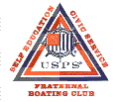

September 2007
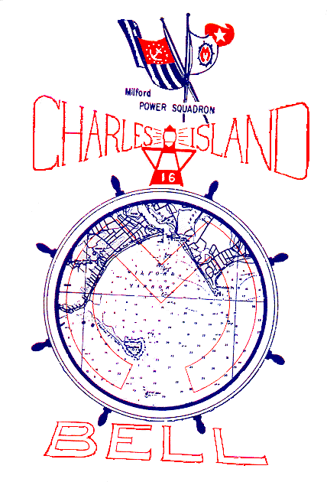

Bridge Officers & Chairpersons
Commander Al Mongillo, AP
203-734-5213 amongillo01@snet.net

Executive Officer Bruce Ross, P
203-378-9780 bruce2sail2aol.com

Financial Officer William Rinckel, S
203-758-5890 wrinckel@us.ibm.com

Education Officer Bob Reeves, SN
203-876-8261 bobr876@aol.com

Administration Officer Hank Chmielewski, AP
203.878-5203 henry.j.chmielewski@snet.net

Secretary Bill Carotenuto , AP
203.734-5453

Membership C/P Bob Post
203-878-0107 rpost2@snet.net

Audit C/P Tony Barbieri
203.874-4214

Vessel Safety Check C/P Hank Chmielewski, AP
203.878-5203 henry.j.chmielewski@snet.net

Computer C/P Bruce Ross, P
    - bruce2sail2aol.com

Public Relations C/P Bob Reeves, SN
203.876-8261 bobr876@aol.com

Port Captain Bob Reeves, SN
203.876-8261 bobr876@aol.com

Co-Op Charting C/P Al Mongillo AP
    - amongillo01@snet.net

Bell Editor Gabe Cordova, S
    - gabeski@optonline.net
Please pay our website a
Visit and key in
www.usps.org/localusps/milford

Milford Power and Sail Squadron Education Course Calendar | Course For | Public & Members | Public & Members | Public & Members | Public & Members | Members | Public & Members |  | To sign up for any of these courses call Bob Reeves Education officer at 203-876-8262. We are looking for members interested in Elective courses. Our instructors are prepared to provide instructions in Seamanship, Piloting, Advanced Piloting, Marine Electronics and GPS, Sailing, Engine Maintenance and Kayaking. If interested contact Bob Reeves.
Milford Power and Sail Squadron Education Course Calendar | Instructor | Bob Post | Bill Carotenuto | Bruce Ross | Dennis Belenger | Dennis Belanger | Al Mongillo
Milford Power and Sail Squadron Education Course Calendar | Location | Foran HS | Fowler Building | Fowler Building | Fowler Building | Egan Center | Fowler Building
Milford Power and Sail Squadron Education Course Calendar | Time | 7:00PM -9:00 PM | 7:00PM -9:00 PM | 7:00PM -9:00 PM | 7:00PM - -9:00 PM | 7:00PM - 9:00 PM | 7:00PM - 9:00 PM
Milford Power and Sail Squadron Education Course Calendar | # Wks | 4 weeks | 2 Hour | 2 Hour | 2 Hour | 6 weeks | 2 Hour
Milford Power and Sail Squadron Education Course Calendar | Day | Wed | Thursday | Thursday | Thursday | Wed | Thursday
Milford Power and Sail Squadron Education Course Calendar | Start Date | 19SEPT07 | 18OCT07 | 25OCT07 | 08NOV07 | 14NOV07 | 15NOV07
Milford Power and Sail Squadron Education Course Calendar | Course Title | Boat Smart | Seminar #1 Charting | Seminar #2 GPS | Seminar #3 Radio | Piloting | Seminar #4 Weather

Commander’s Report

With The Labor Day Weekend upon us, we are fast approaching the end of the 2007 boating season with only about 2 more months to go. However, the fall season often offers up some spectacular boating weather, void of the heat and humidity that often accompanies summer cruising. And for the fisherman things also start to pick up with the blues and stripers feeding actively before they start there winter migration.

This is also a perfect time of the year to plan to take one of USPS’s traditional education courses or attend one or two of the NEW 2 hour seminars USPS is offering on a variety of topics. They will include GPS use, VHF /VHF DSC (Digital Selective Calling), Onboard Weather Forecasting and Charting. Please refer to the table in this month’s Bell for dates, times and instructors. Our thanks for out to SEO Bob Reeves for the time and energy he has put in, as well as the great job he has done, to plan these courses and arrange for dates and times. Please reward him with your interest and attend one of these offerings, since as we all know, education is the heart of USPS and Milford Power Squadron.

Thus far this year a number of people have been active supporting and promoting MPS activities. The entire education team, including Bill Carotenuto, Bob Post, Hank Chmielewski, George Buffington, Tony Barbieri and Bruce Ross has been very active in achieving our goals to providing the greater Milford area with traditional USPS Boating Courses, as well as Bruce’s very successful Kayaking Course. Dennis Belanger has also recently come aboard to bolster up our teaching corps, bringing with him his naval and business training and teaching experience.

Thanks to Co-Chairs Dottie and Roger Johns, we once again had a great location on the Milford Green for our MPS booth at this year’s Oyster Festival. Hank Chmielewski volunteered his day, supported by Bruce Ross and me, to discuss our educational offerings coming up this fall as well as try to sell the merits of Milford Power Squadron membership. We estimated that we had about 200 inquiries for our CT certification course. This should be music to SEO Bob Reeves ears. In addition, our Vessel Safety Check Team conducted over 50 examinations, thanks to the dedication and
Planning of our VSC chairman Hank Chmielewski. In addition to personally conducting over 20 VSC’s our newly appointed Treasurer,

Bill Rinckel, has done a great job to create digital accounting process for recording all financial activities.

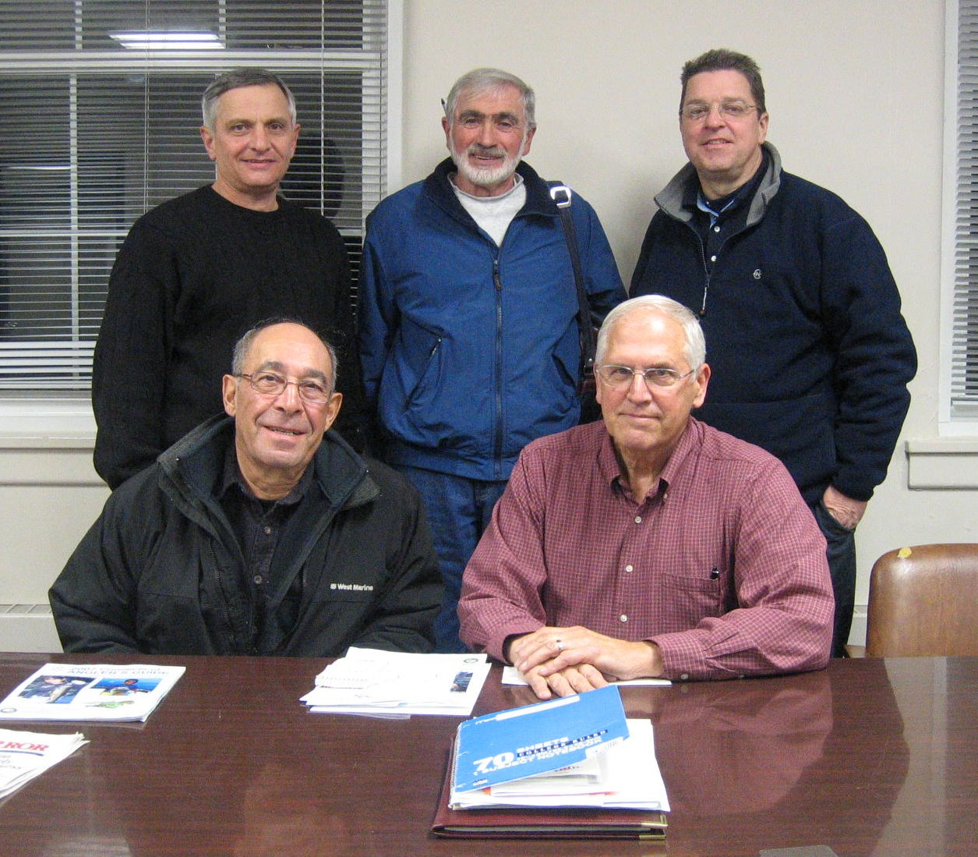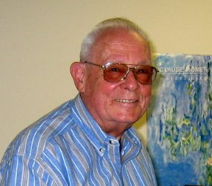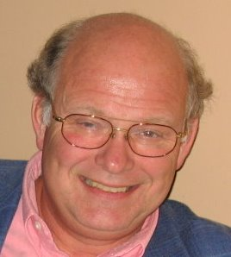

Bridge Members shown in the photo are: Group standing, Al Mongillo, Bill Carotenuto, and Brice Ross, and seated, Gabe Cordova and Hank Chmielewski. Individual photos are Bob Reeves (Left) and Bill Rinckel. Your Bridge and committee chairpersons are actively working to get out into the community and serve the boating public. Please support our efforts by volunteering your time to support these activities and contacting me at 203-734-5213 or amongillo01@snet.net.

All MPS members are invited to attend our monthly Bridge meetings to see what is going on behind the scenes. Our next meeting is tentatively scheduled for Thursday September 20 at the Margaret Egan Center in Devon, 7 P.M. Room TBE. Please call me if wish to attend and I will provide an update. There are a number of activities that are available for anyone willing to give a few hours a month of their time. We especially need a dedicated Membership Chairperson and a Squadron Historian.

Lastly, please look to our calendar of events for what is coming up this fall. The next District 1 events are the October Council Meeting and November Fall Conference.

Cdr Al Mongillo

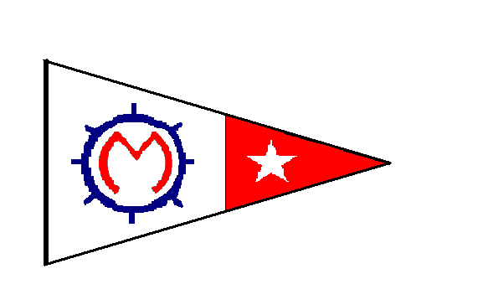

Milford Power And Sail Squadron

PILOTING COURSE
(FOR USPS MEMBERS ONLY) This is the next step in your boating education.
CONTENT:
Charts and Digital Charts Dead Reckoning

Introduction to GPS Chart Reading
Publications and their Use Electronic Charting
Bearings
Latitude & Longitude Determining a Fix
Aids to Navigation Navigation Rules
Mariners Compass Plotting and Labeling

Plotting, Plotting and more plotting
WHEN: Starting Wednesday November 14 and every Wednesday, once a week. For about 6 weeks-7:00-9:00 PM.

WHERE: Margaret Egan Center, Devon, --Room 136
Dennis Balenger will be the Instructor

COST: New course material- Cost $60 - Please bring your own plotter and dividers.

TO REGISTER: If you want additional information on the course or to register for the course contact :
BOB REEVES ,SEO, Bobr876@aol.com 203-876-8261.

DIRECTIONS: Going south on Naugatuck Ave. from the Boston Post Rd. in Devon, you will pass 1 light after the light on the BPR and Naugatuck Ave. Go one block past the light and turn right which is Mathew St. The Center is at end of short street on right.

After completing Seamanship and Piloting your next step is Advanced Piloting

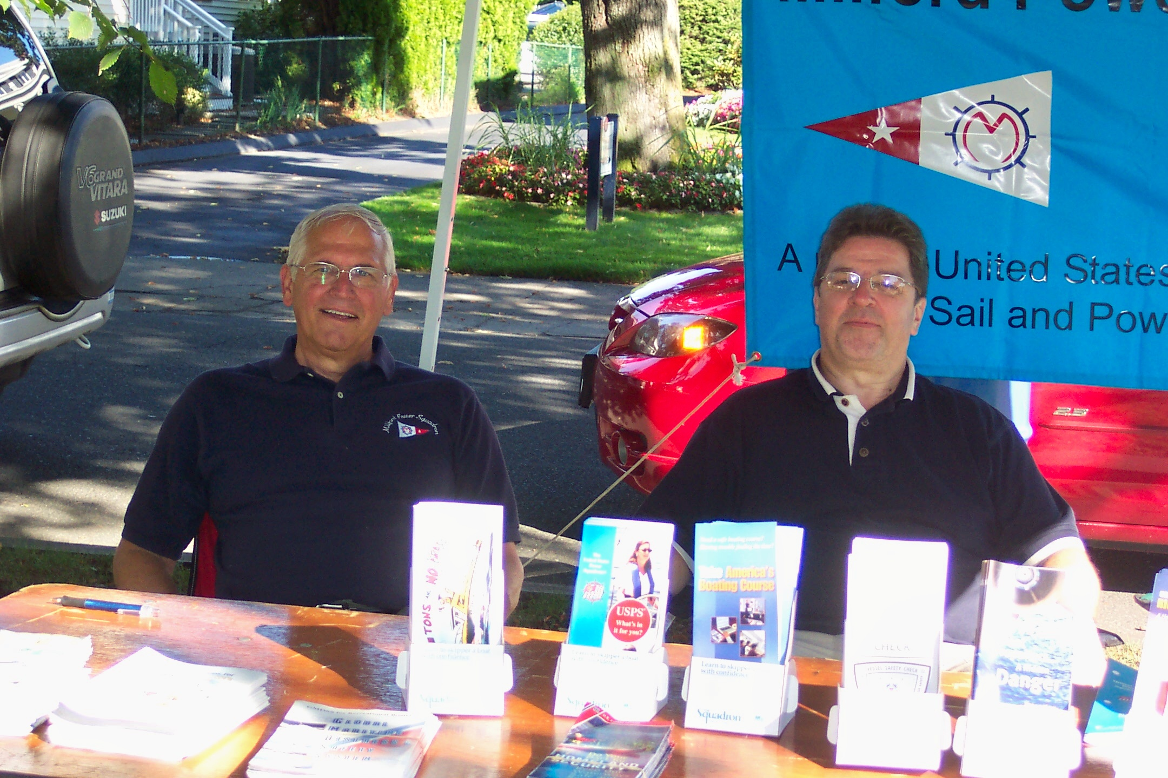

Hank Chmielewski and Bruce Ross on Booth duty at the Milford Oyster Festival.

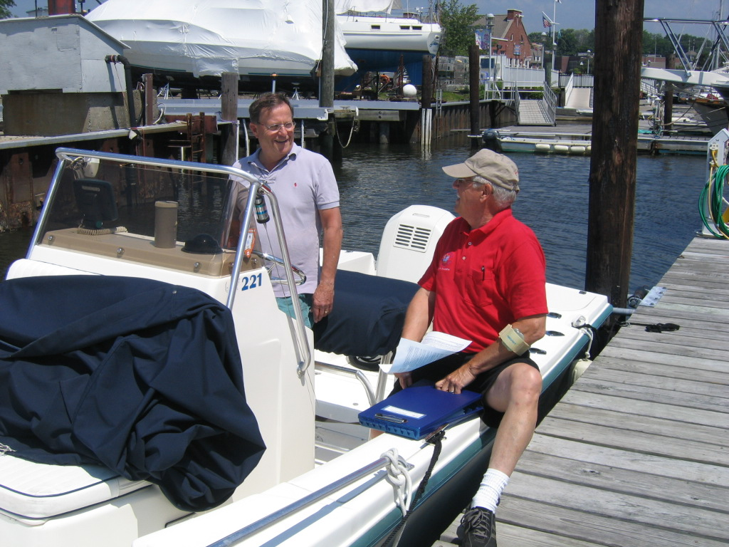

Hank Chmielewski performing Vessel Safety Checks at Milford Boats Works on Sat June 16.

