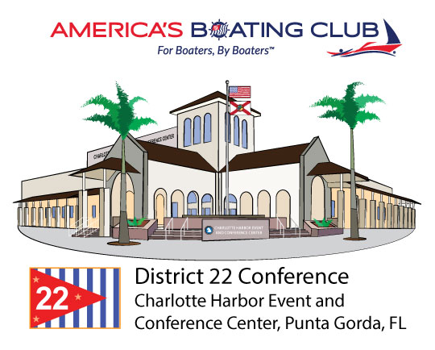

2021 Winter Conference

Due to Covid issues, the ‘in-person’ Meeting scheduled for

Tuesday, 5 January 2021

has been switched to a

Virtual Conference

Schedule:

Council member electronic voting 11-12 January 2021

District member electronic voting 13-14 January 2021

(elected/appointed delegates will receive detailed information via email)

Virtual Conference Meeting

Saturday, 23 January 10:00am – 12:00pm

(watch for zoom instructions in January, prior to the meeting)

Important Matters to be covered:

Officer Reports

Committee Reports
Conference - Rules - Planning - Audit - Budget
Presentation of Awards
D22 Website Update, with intro to Manatee site

Looking forward to gathering with our fellow members

9 and 10 April

At 2021 Spring Conference with Change of Watch!

