HQ-800
‘How-To’ for America’s Boating Course (ABC3) A Step-by-Step Quick Guide

Introduction
This step-by-step user’s Quick Guide explains what HQ-800 is all about, who should use it, and the basic steps to get it up and running for squadron use. A number of supporting resources will also be described, including a guide for advanced users and a PowerPoint training module useful for district training of new HQ-800 users. This ‘Quick Guide’ will also serve as a reminder for the infrequent user on signing on and using HQ-800.

Simple, “BY THE CLICKS” listing, is presented in the last four pages for those needing only a reminder for REGISTRATION, ENROLLMENT and REPORTING.

What Is HQ-800?
HQ-800 is an internet-based computerized system to assist in managing all aspects of conducting public boating courses, America’s Boating Course 3rd Edition (ABC3) and other USPS seminars and courses. For simplicity, this Quick Guide concentrates exclusively on ABC3. The HQ-800 system includes features for:
• REGISTRATION: Setup & advertise an ABC3 class in advance of the actual course. The software links your class information to Boat/US for placement on their boating safety classes’ page, provides the respective Boating Law Administrator (BLA) with class information which may be posted on the respective state boating safety classes page, and is copied to your District Educational Officer (DEO).
• ENROLLMENT: To collect and organize all of the student data.
• REPORTING: To report the ABC3 course results after administering the final exam.

Who Should Use HQ-800?
The squadron’s ABC3 class instructor should use HQ-800. Squadron personnel authorized to make changes are: SEO, ChLB, and Squadron Cdr. District leaders authorized to make changes to a squadron HQ-800 posting include the ADEO and DEO. There is a training and experimentation mode within HQ-800 that any USPS member may use by first signing on as an active USPS member and then using a virtual squadron named ‘NoneSuch’ and squadron code 5999. Examples will be provided using ‘NoneSuch’.

Why Should I, as a Squadron Officer, Use HQ-800?
USPS is obligated to provide ABC3 class schedules and results to most states. HQ-800 satisfies this written obligation. In addition to sending class results to USPS Headquarters in Raleigh, HQ-800 also makes the ABC3 class data available to the state’s BLA.

Is There Another Tool That I Can Use Instead of HQ-800?
Yes, the Boating Course Assistant (BCA7) computer application package provides essentially the same functions as HQ-800. BCA7 is a standalone Windows-based software application that must be downloaded and installed on a user’s home or squadron computer. HQ-800 is an internet-based system that will run on any computer using a standard browser such as Internet Explorer, Firefox, Safari, Chrome, etc.

The choice is yours to make, but each squadron must use either HQ-800 or BCA7 to report the results of all ABC3 classes. We do not recommend starting a class process in one system and finishing in the other system, since this may cause data problems between the two systems.

OK - - SHOW ME HOW-TO USE HQ-800
First, you should know that HQ-800 is a very thorough system with numerous options. Many of the options you may never use. You should experiment using the virtual squadron named ‘NoneSuch’ to learn about the various options and to practice with those options that will help you to get the job done quickly and easily. This Quick Guide will get you started with the basic options needed for:

REGISTRATION, ENROLLMENT, and REPORTING. THESE SAME STEPS WILL BE USED FOR ENTRY OF ACTUAL SQUADRON CLASS INFORMATION.

Start by using your favorite browser (Internet Explorer is recommended) and going to the USPS Member Logon page and signing in with your certificate number and PIN:

http://www.usps.org/cgi-bin-nat/tools/pages.cgi?logpage

TIP: Once logged in do not exit your browser else it is likely that you will have to login again once you attempt to enter the HQ-800 system.

You may access the HQ-800 system either of two ways:

Option 1: Direct link for the options to ‘Manage Public Programs’: http://www.usps.org/eddept/menu_lists.htm#public and then select the option to ‘Register Boating Courses (HQ-800)’.

Or

Option 2: By going to the EdDept home page at http://www.usps.org/eddept and clicking on
‘Manage Public Programs’ and then clicking ‘Register Boating Courses (HQ-800)’.

The term ‘Register Boating Courses …’ is somewhat of a misnomer; it is actually the starting point to enter the HQ-800 online system. Both of the above links will take you to a page that looks like the following; fill in the Squadron field and the Account field with your squadron information. To practice and experiment with the HQ-800 system use ‘NoneSuch’ in the Squadron field and ‘5999’ in the Account field as shown below.

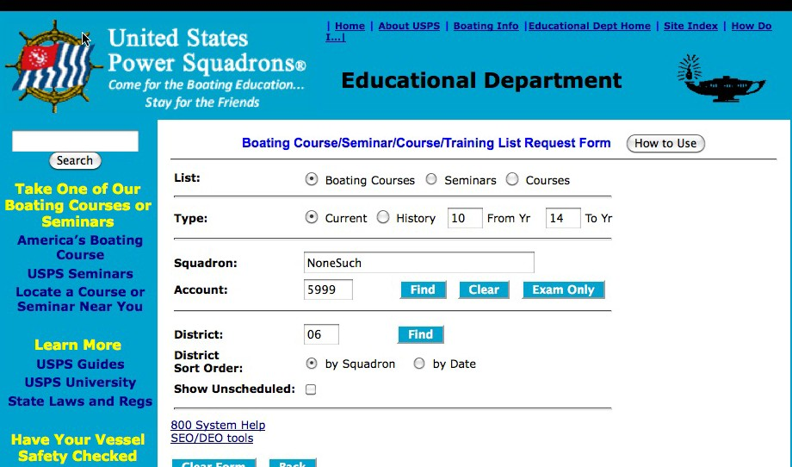

There are three options shown in the ‘Squadron’ area of the page; to limit the size of this guide, the
‘District’ area will not be addressed (you may experiment with the District ‘Find’ option if desired):

FIND: this option will show all the ABC3 courses posted for the squadron; you may use your actual squadron and account to review your team’s ABC3 listings, but no changes will be permitted unless you are an authorized officer.

CLEAR: this option just clears the squadron name and account number fields from the screen shown above.

EXAM ONLY: this option permits an authorized HQ-800 user to post the in-person, proctored exam results for a single student such as an ON-LINE ABC3 student completing the program.

REGISTRATION:

Start by entering either ‘NoneSuch’ or ‘5999’ in the appropriate field (only one item is actually necessary) and click on ‘Find’. This will take you to the Boating Course Registration List for the
‘NoneSuch Squadron’. There should be at least one default record on that page, but there may be several depending upon the use of this training aid. Select an item from that page by clicking on the
“+” sign in front of the course; the details for that particular course will be displayed.

Note: For the purpose of this demonstration with NoneSuch no actual notices are sent to the DEO or BLA or Boat/US, just to you the individual listed as the course contact.

To continue experimenting with the HQ-800 options, register a new ‘NoneSuch’ class by selecting any existing class record by clicking on the “+”, then changing the information to that for your new class.

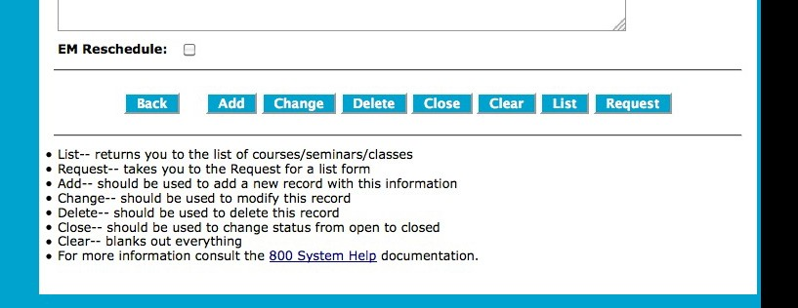

Set the ‘Start’ date to a future date and update or change the remaining entries to be consistent with the new class information. If these changes constitute a new class (like if you are using an ‘old course’ listing as a template for a new course), click the ‘Add’ button and a new class listing will be generated. If changes are made to an active course listing (after a course has been registered), such as time or place, click on ’Change’ when finished, i.e., ’Change’ represents changing the information on an active course listing. After clicking on ADD or CHANGE, click on SAVE.

Tip: Checking the “Allow On-line Registration” helps enroll web searchers. Entering a fee in the ‘Non-Mbr’ box leads to course advertising with Boat/US. If no advertising is desired enter fees only in the ‘Mbr’ box.

Click the ‘List’ option and then on the “+” option to verify that the new course information, conditions and features for the course are correct. The “+” re-displays the details of the new ‘NoneSuch’ course listing.

You should experiment with the other options shown on the screen.

ENROLLMENT:

‘Enrollment’ is the process of adding students to the class roster. Students may be entered as they sign up for the course or after the registration session that is usually part of the first class session.

To add a student(s) to the class roster, open that specific class listing by clicking on the “+” as described in the foregoing REGISTRATION section. This is the ‘Details’ page as noted in the title of the page. Click on the ‘Enrollment Management Tools’ button as shown below:

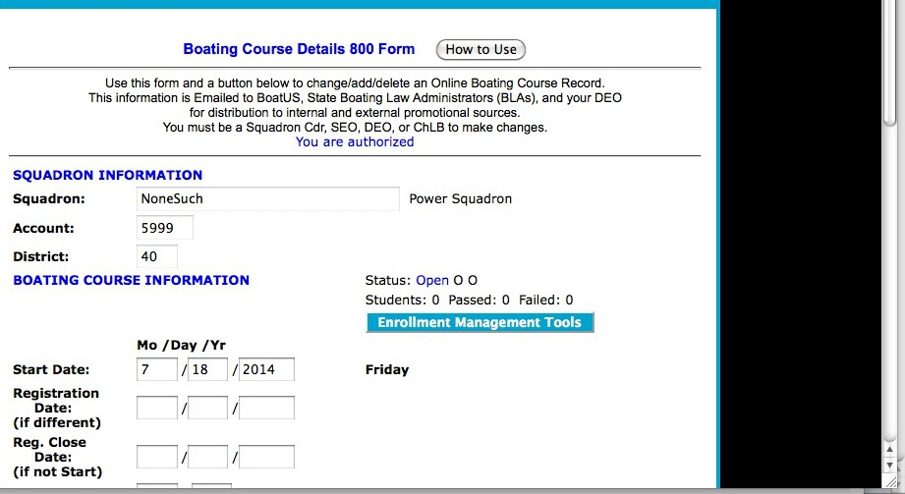

Clicking the ‘Enrollment Management Tools’ button will display the following page:

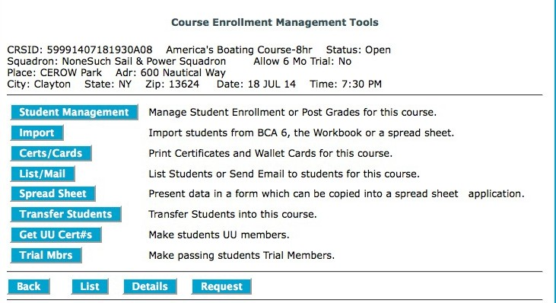

Use the ‘Student Management’ button to advance to the ‘Course Enrollment Management’ page and add new students, or to revise the data of students already entered. There are numerous other options with which you should experiment within this training aid and via ‘NoneSuch’. The essential tool for this step is the ED-46 USPS Boating Course/Seminar/Course Registration Form (downloadable from the EDDEPT Forms Page http://www.usps.org/national/eddept/files/forms.htm). When filled in by the student, the information is presented in the sequence needed for transcribing into HQ-800.

On the ‘Course Enrollment Management’ page, enter data for each of the students. You need name, address, telephone number, sex, DOB, hair color, eye color, height. For this demo with ‘NoneSuch’, make up this information. When done, click ‘Save’ (scroll down if necessary to locate the ‘Save’ button).
On the results page, click ‘Re-Display’ then ‘Clear’ to populate the student list at the bottom of the page to see if the data for the new student(s) was entered correctly. Notice that each student has a ‘list’ number prior to their name. Notice also, that there is an empty box within the line with all the buttons, preceded by a “#” symbol.

For the details of each enrolled student to be displayed, enter the student list # from the list at the bottom of the page into the empty box, then click on ‘Show’; note the magenta status field before the
‘Grade’ field is E (for entered); the source field after the ‘Grade’ field is O (for online), and the data entry date is displayed. This procedure is also used next in the REPORTING phase to enter the final examination grade for each student.

There are numerous other options, all there for your use and experimentation. REPORTING:
Before reporting the results of an ABC3 class, the exam scores for each student must be entered into
HQ-800. To enter the exam scores for students, open the class record in the same manner you did for
‘Enrollment’. Click on ‘Enrollment Management Tools’. You now should have a page last used in the ENROLLMENT phase.

Click on the STUDENT MANAGEMENT option in the list, then in turn enter the number assigned to the student in the student listing in the “#” box, followed by SHOW, then enter each student’s final examination grade. When done, click on ‘Save’ then “CLEAR” and move to the next student. In this case, the grades for students may have already been entered since this is a general training aid used by numerous squadron members. Enter passing grades (i.e., greater than 79) and at least one non-passing (i.e., less than 80). Click ‘Save’. For the student(s) who failed the exam, there will be a box with his/her exam grade that can be changed later on a successful re-examination.
• Click SAVE
• Click LIST to confirm all is in order
• Click ‘Clear’ (to re-populate the student enrollment list).
For those passing, an ED26 (Student Information Form) is transmitted to USPS Headquarters in
Raleigh. For those failing, nothing happens, other than posting a grade. Failing grades will be used as part of the ED27 (Course Completion Report to the SEO / DEO / BLA). The ED27 is sent automatically on the morning after the ED26 data is transmitted to HQ, and consists of numbers of registrations, failures and graduates. For the ‘NoneSuch’ Squadron, ED27s are sent only to you.

Tip: With student concurrence, enter the graduate in the “trial membership” program. The student is automatically assigned an “E” member number and will show on your next-day membership update.

That’s it … you are done, except for printing the Course Completion Certificates and Wallet Cards!! To print, use the ‘Certs/Cards’ button on the Course Enrollment Management Tools page mentioned previously. Instructions will be provided in each step of the printing cycle.

ADDITIONAL TIPS AND RESOURCES

There is an extensive HQ-800 Help System; it consists of the following parts:

• The "800 System Life Cycle" document which gives you an overall picture of the events involved with Boating Course, Seminars, and Course Offerings management and when functions can and should be performed. It is broken down into three primary sections: Public Boating Courses; Seminars; and Advanced / Elective Course Offerings.
http://www.usps.org//cgi-bin-nat/eddept/pages.cgi?tools/SEO/800_WF:Y

• The "800 Services" document which is a road map for determining how to get to the form/page that allows you to perform a function. It is broken down into three primary sections: Public Boating Courses; Seminars; and Course Offerings.
http://www.usps.org/cgi-bin-nat/eddept/pages.cgi?tools/SEO/800_Services:Y

• The "800 Certificate Numbers and Membership" document which attempts to clarify how the HQ-800 system uses certificate numbers to create permanent records of completions and how it works with membership software to create USPS University (UU) Memberships and Trial Memberships.
http://www.usps.org/cgi-bin-nat/eddept/pages.cgi?tools/SEO/certs_and_membership:Y

• Every form and page in the HQ-800 system has a ‘How to Use’ button which when clicked provides detailed information about the functions which can be performed using the page or form.

TIP - Printing ABC3 Course Completion Wallet Cards from HQ-800 Software
ABC3 course completion wallet cards are pre-printed with 10 cards to a sheet. This presents challenges for the manager to prevent waste and get the printing done correctly the first time. The “HOW TO USE” directions in the HQ-800 for this effort include:
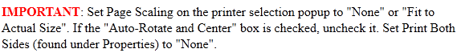
It is always useful to run a test printing on a blank page when adjusting to various printers. Print, then compare the test page to the pre-printed card to check alignment.
When printing fewer than all 10 of the cards on the wallet card sheet, start at the bottom of the sheet which allows the printing to remain aligned. If you start from the top there is not enough paper to keep the sheet aligned. I've used this system several times and have great results.
Resources - HQ-800 User Self-Help / Education
Each district and squadron change-of-watch brings new leadership into our Educational Department. Registering and reporting course and seminar completions is a vital element of our educational system, accomplished through either of two software programs, and the subject of much correspondence with members. Several entries on this site in recent years have provided guidance for the new leaders and sometimes the seasoned educators, on use of one program, HQ-800 software. This “Quick Guide” provides distilled information with focus on individual self-teaching and group learning presentations. The significant element to these initiatives is that a fictitious squadron (NoneSuch # 5999) has been created to allow learners to enter data as though it was real for purposes of training. The self-teaching and group learning components are as follows:
- Using Squadron “NoneSuch” (5999) for HQ-800 Boating Course Registration, Enrollment and Report Training (72KB, PDF)
http://www.usps.org/national/eddept/b/files/hq800-training_boating-course.pdf

- Using Squadron 5999 “NoneSuch” for HQ-800 Seminar Training (87KB, PDF)
http://www.usps.org/national/eddept/b/files/hq800-training_seminars.pdf

- HQ-800 Tutorial Presentations (5781KB, Zipped PPTX)
http://www.usps.org/national/eddept/b/files/hq800-tutorial.zip

The first two documents, based on fictitious squadron NoneSuch #5999, are PDF files that allow members who are unfamiliar with HQ-800 software to try out the procedures to register a course or seminar in the program, administer student registration, enter student information for uploading to the National data base and note the “proof of receipt” in an ED-27 report, all without actually entering false data on the National data base. These two aids are excellent learning tools for new DEOs and SEOs.
There are four PowerPoint files, compressed into item 3 above along with an explanatory Word file, that form a comprehensive tutorial that operates live; there are no practice scenarios. There is a main menu presentation, plus Part A which is essentially the “live” portion of the first two listed “NoneSuch” squadron presentations. Parts B and C take the viewer through printing certificates, printing wallet cards, and listing enrollees. This is an excellent teaching aid for district council meetings and conferences. NOTE: The HQ-800 PowerPoint presentation may be viewed in two modes: (1) the normal mode, which includes the slides and explanatory/speaker notes and is recommended for those accessing this help section for the first time, and (2) the slide show mode, which is recommended for those who feel fairly comfortable with the HQ-800 system. Note that all four .PPTX files MUST be in the same directory/folder for the Slide Show mode to work properly. See the Word document in the zipped file for details. Questions or comments should be directed to the Basic Public Education Committee:
http://www.usps.org/cgi-bin-nat/tools/docom.cgi?13170

If all else fails and you are at your wits’ end, you may contact the Basic Public Education Committee using the HQ-800/ABC3 Help Form at http://www.usps.org/national/eddept/b/bpecom_form.htm . This form is also accessible from the BPECom home page at http://www.usps.org/national/eddept/b . “BY THE CLICKS” listings follow for those familiar with the 800 system and need only a refresher sequence.

